Business Requirements Document

CMS Onboarding Forms Consolidation

Version: 0.9

Date Last Published: 10/6/2019

Date Signed: 9/17/2019

Author(s): James McFarlane

***Do not*** *arbitrarily add or remove sections within this document as it raises the risk of diluting the standard. If the unique nature of the initiative requires additional sections, add these and organize as Appendices. Rather than removing specific sections, explain why the section is not needed along with “Not applicable”.*

Tamara Scanlon

# Document Information

## Revision History

|  |  |  |  |
| --- | --- | --- | --- |
| Version | Date | Authors | Revision Notes |
| 0.1 | March 29, 2018 | James McFarlane | Creation |
| 0.2 | May 1, 2018 | Tamara Scanlon | Edits |
| 0.3 | May 11, 2018 | James McFarlane | Sign off |
| 0.4 | 7/9/2018 | James McFarlane | * Addition of Appendices with field mapping * Updated eSignLive to OneSpan Sign * Lowered priority of compatibility with OneSpan Sign * Addition of requirements for signature, and the output * Addition of Business Rule surrounding Multi Entity Organizations * Addition of requirement for compatibility with FileNet |
| 0.5 | 11/29/2018 | James McFarlane | * Updated based on CR-01 including   + Removing Click to Sign   + Add Save prior to Sign   + Add option for Auto Save   + Removing Internal Forms   + Including audit on the output   + Updating fields * New information if in orange text |
| 0.6 | 3/8/2019 | James McFarlane | * Additional verbiage added to FUNC004 to describe desired functionality on output forms new verbiage in green text |
| 0.7 | 4/24/2019 | James McFarlane | * Adding BR036, FUNC032, & FUNC033 to clarify expected behavior around signatures. New verbiage in blue text |
| 0.7 | 4/24/2019 | James McFarlane | * Added the MSA in Appendix E |
| 0.8 | 8/16/2019 | James McFarlane | * Adding triggers for the when to provide child form |
| 0.8 | 8/16/2019 | James McFarlane | * Adding requirements for CMS support section and that all info gathered will be provided will be provided to the client |
| 0.8 | 8/16/2019 | James McFarlane | * Updated Legend |
| 0.8 | 8/16/2019 | James McFarlane | * All updates for 0.8 are in indigo text |
| 0.9 | 10/6/2019 | James McFarlane | * Added detail for FUNC019 to show type of modification as per CR004 |
| 0.9 | 10/6/2019 | James McFarlane | * Added clarity that MSA does not have to be provided for Delete, or for Visa Only |
| 0.9 | 10/6/2019 | James McFarlane | * All updates for 0.9 are in teal text |

## Review and Contributions

|  |  |  |  |
| --- | --- | --- | --- |
| Version | Name | Role | Title |
|  |  |  |  |
|  |  |  |  |

## Related Document References

|  |  |  |
| --- | --- | --- |
| Ref | Document Name | Short Description and URL |
| 1.0 | CWB Logo Use Standards | Guidelines on the use of the CWBs logos and coloring. |
|  |  |  |

# Glossary

## Acronyms

|  |  |
| --- | --- |
| Acronym | Full Text |
| CMS | Cash Management Support |
| cRDC | Corporate Remote Deposit Capture |
| CAFT | Customer Automated Funds Transfer Agreement |

## Terms

|  |  |
| --- | --- |
| Term | Definition |
| OneSpan Sign | Formerly eSignLive is the e-signature solution currently used by Virtual Branch |
| Form Wizard | The initial application that data is gathered on |
| Child Forms | The existing forms where data gathered in the Form Wizard is populated onto (e.g. Visa information is gathered on the Form Wizard and populated onto the 4097 child form) |

Table of Contents

1 Document Information 2

1. Revision History 2

2. Review and Contributions 2

3. Related Document References 2

2 Glossary 3

1. Acronyms 3

2. Terms 3

3 Document Purpose 6

3.1 Document Scope 6

3.2 Document Intended Audience 8

4 Business Overview 9

4.1 Business Problem Statement 9

4.2 Business Need and Key Objectives 9

5 Strategic Alignment 10

6 Stakeholders 10

6.1 Sponsor Information 10

6.2 Stakeholder Information 11

7 Requirements Approach 12

8 Requirements 12

8.1 Business Requirements 13

8.2 Regulatory Requirements 14

8.3 Stakeholder Requirements 14

8.4 Solution Requirements 14

8.4.1 Functional Requirements 14

8.4.2 Non-Functional Requirements 16

8.5 Transition Requirements 16

9 Assumptions, Dependencies and Constraints 17

9.1 Assumptions 17

9.2 Dependencies 17

9.3 Constraints 17

10 Business Benefits 17

11 Business Risks 18

12 Business Rules 19

13 Signature 19

# Document Purpose

A Business Requirements Document (BRD) is an industry standard, formal document that provides an agreement between a “supplier” and a “client”. The “client” is the business area. The “supplier” is the IT department that will create and deliver the new product, system or process. This document is written in response to a known business problem or shortcoming and details the needs and expectations of a business area. The objectives are to:

* Gain agreement with stakeholders.
* Provide a foundation to communicate to a technology service provider what the solution needs to do to satisfy the client areas' needs.
* Describe what (not how) the business needs will be met by the solution.

The BRD does not describe the solution in detail, for technical products such as software systems, further technical specifications will be prepared and distributed alongside this document, prior to development.

## Document Scope

The objective of this project is to create a “one-stop shop” for all activities of Cash Management Products, such as adding, changing or removal. The vision is to consolidate all pertinent forms into one new intake ‘form’. This new ‘form’ will capture all required information for the actives and products selected (e.g. Onboarding Remote Deposit Capture and change of Business Online Banking credentials). Once completed, the user will have an option to print the document ~~to sign~~ ~~or click to sign~~ for a physical signature or email for a digital signature. A new consolidated Master Service Agreement (MSA) will replace all related Terms & Conditions (T&Cs) documents.

***!Note:*** *The printing of the new form will also incorporate the associated vendor forms required (e.g. RDC form for C1, Wires for Western Union etc.)*

**In Scope:**

* Consolidate all New, Modify, Delete requests for the following ancillary products into one intake “form”*:
  + Online Wires,
  + Business Online Banking,
  + CAFT,
  + Corporate RDC,
  + Business VISA
* Remove the “In Scope” form list (below) from general use
  + The forms will available to be used as backup, if required
* Allow the option for the customer to sign via:
  + ~~Click to sign, or~~
  + Print & get for wet ink signature (upon request) or
  + email for a digital signature
* Consolidate all Terms & Conditions for these ancillary products into one Master Service Agreement
* Apply current branding standards to all outputs
* Generate printable Vendor-like forms

**Customer/Branch Forms**

* Form 4288 CWBdirect Business Online Banking Application and Agreement – Delegated including wires sections – All instances Online Banking – New Modify Delete
* Form 4056X – Online Banking – New (Note the Non-Delegated needs to remain on InfoServer – Delegated option to be removed) medium priority for removing delegated option on infoserver
* Form 4209 CWBdirect Business Online Banking User Permissions – including wires sections CWBWires New Modify (Note the Non-Delegated needs to remain on InfoServer – Delegated option to be removed) medium priority for removing delegated option on infoserver
* Form 4335 CWB Wire Service Checklist – CWB Wires - New
* Form 4336 Standalone CWB Wire Service– CWB Wires – New Modify Delete
* Form 4122- CAFT Customer Automated Funds Transfer Agreement for Direct Deposit (Credit Files) – CAFT New – Only used If File transaction Type is “Credit”
* Form 4129- CAFT Customer Automated Funds Transfer Agreement for Pre-Authorized Debits (Debit Files) – Only used if File transaction Type is “Debit”
* Form 4164 – CAFT Onboarding form– CAFT New Modify Delete
* Form 4028 – CAFT Credit File Risk Assessment– CAFT New Modify – Only used when File Transaction Type is “Credit” and “Maximum Value of a File” is not null
* Form 4163 – CAFT File Upload information form – CAFT New Modify – if Originator Type is “File Upload” and Returned Account Number has been entered
* Form 4338 RDC Application and Agreement – RDC New Modify Delete
* Central 1 RDC form– RDC New Modify Delete
* Form 4097 Business Visa Application– Visa New
* Form 4293 Request for Visa card changes - Visa Modify Delete
* Form 4294 Business Visa – Credit Limit Increase– deleting as information is covered on Comet – needs to be taken off InfoServer
* ~~Form 4289 Visa Disclosure~~
  + We will be changing providers for this product August 2018, but will continue to use the same forms
* 4111 CAFT Checklist – Taken out no longer required – remove from InfoServer

**Internal forms**

* ~~CAFT (Form 4161)~~
* ~~Business Visa (Springboard Online Card Management Tool Internal Request Form)~~
* ~~CWB Wire Service – corporate office departments only~~
* ~~CWBdirect Business Online Banking Application & Agreement – Non-Delegated~~
  + ~~This product is being phased out and will require special onboarding outside of this new process (use existing forms)~~

***\*Note****: The technical process of collecting all the pertinent information and generating “forms” has not yet been determined.*

**Out of Scope:**

* Integration with OneSpan Sign
* Integration with any other systems (e.g. T24, WAVE etc.)
* Any forms not listed within the In Scope section

This document contains requirements at the level of detail understood by the stakeholders at this point in time. Content will be updated to reflect new information as it becomes available. Therefore, any printed copy of this document is considered invalid.

## Document Intended Audience

This document contains confidential information intended for the specific audience listed below. The information in this document may also be legally privileged. If you are not listed below, please contact the document author noted on the front page.

* Kristen En, ~~Business Sales & Marketing Specialist,~~ Product Manager, Cash Management
* ~~Ram Sidhu, Manager, Digital Sales & Marketing~~
* Jo Gould, Senior Manager, Cash Management, ~~Sales & Marketing~~ Client Solutions
* Diana Tran, SME
* Alaa Moursel, Administration Officer, CMS
* Gurdy Bains, Mgr, CMS
* Marilyn Kontz, Organizational Change Advisor, OCM Branches
* Dale King, AMS Analyst
* Terri Pyne, Snr AMS Analyst
* Kris Aloisio, Snr Application Developer
* Lisa Rindero, Mgr, Application Support
* Jane Teo, Mgr, AML Program Development
* Soni Samra, AVP & Snr Legal Counsel
* Lindsey McTavish, Assistant Manager Operations
* Kinjal Manek, Senior Manager, Learning & Development
* Tamara Scanlon, Senior Business Analyst
* James McFarlane, Business Analyst

# Business Overview

Currently when business clients are signing up for new ancillary products or services they are presented with separate onboarding forms, each with their own Terms and Conditions. The 5 CMS products that are in scope for this initiative are Online Wires, Business Online Banking, CAFT, RDC, and Business VISA.

While these forms require a lot of the same information they can use different language, and have different field names. Not only is this confusing and time consuming for the client, it has regularly led to errors. These errors can come from the client, or from the branch, and cause significant rework for CMS. CMS has to send the forms back to the branch indicating the corrections necessary. The branch is required to obtain the correct information from client. This process can significantly extend the length of time before a client has access to these products, leads to a poor client experience, and damages the reputation of the bank.

CWT, Virtual Branch, Franchise Finance, Maxium all have branches that fill out these forms and send to CMS.

This process also has a high financial/environmental cost as the forms and associated Terms and Conditions are multiple pages in length and physically printed out.

## Business Problem Statement

|  |  |
| --- | --- |
| The problem of: | Multiple forms for ancillary products |
| Affects: | Clients, Branches, CMS |
| The impact of which is: | Duplicating work filling out these forms and multiple errors requiring correction |
| A successful solution would be: | Consolidate the forms for ancillary products using clear concise language |
| Resulting in the benefit of: | A streamlined onboarding process with less work involved filling out forms and correcting errors. |

## Business Need and Key Objectives

Our desired solution is an application that branch staff will present to clients when they initially set up their accounts. This single online form/application will present the various products available to business clients. When the products the client needs are selected, the form will present the appropriate fields required. Each unique field will only be required to be filled out once even if the name of the field is different in different locations. Once completed the application will auto populate the fields on all the appropriate forms.

Our desired solution also incorporates the delivery of set of Terms and Conditions in a single Master Service Agreement.

# Strategic Alignment

This initiative directly aligns to the following Strategic Roadmap items:

|  |  |  |
| --- | --- | --- |
| Strategic Objective | Description | Alignment |
| S1 | Drive Operational Excellence | The consolidation of onboarding forms will streamline and enhance the customer experience when adding, removing or modifying business products. |

# Stakeholders

The following is a stakeholder analysis:

|  |  |
| --- | --- |
| Area | Impact Analysis |
| Branch | |
| Branch Staff | Branch staff will be the end users of the new application/form. They will use this new application/form when onboarding new business customer products. |
| Cash Management | |
| Cash Management | Cash Management will be the owners of the new application/form. |
| Cash Management Support | |
| CMS | Cash Management Support will be the back office fulfiller of onboarding new, changes and removal of business products. |
| Legal |  |
| Soni Samra, Legal Counsel | Facilitate a consolidated Master Service Agreement to be used for all products. |
| Technical Subject Matter Experts (SME) | |
| Terri Pyne  Dale King | Forms application SMEs.  Will be consulted on best practices and identify application limitations and functionality. |

## Sponsor Information

|  |  |
| --- | --- |
| Business Unit: | Cash Management |
| Department: | ~~Sales and Marketing~~ Client Solutions |
| Department Number: | 162 |
| Business Leader (Executive Sponsor): | Jeff Wright SVP, Client Solutions |
| Business Sponsor (Project Owner): | Greg Noga, SAVP, ~~Sales & Marketing~~ Client Solutions |
| Requestor (Project Lead): | ~~Ram Sidhu, Manager, Digital Sales & Marketing~~  Jo Gould, Senior Manager,  Cash Management |

## Stakeholder Information

|  |  |  |  |
| --- | --- | --- | --- |
| Name and Title /  *Acting Designate* | Stake/Interest | Level of Engagement/Impact | Possible Concerns |
| Kristen En,  ~~Business Sales & Marketing Specialist~~  Product Manger, Cash Management | Provide working group oversight | Low | Availability |
| ~~Ram Sidhu, Manager,~~  ~~Digital Sales & Marketing~~ | ~~Provide working group oversight~~ | ~~Low~~ | ~~Availability~~ |
| Jo Gould, Senior Manager,  Cash Management, ~~Sales & Marketing,~~ Client Solutions | Owner of the form once complete | Low | Availability |
| Diana Tran,  Account Manager Cash Management | Form consolidation oversight | Low | Availability |
| Alaa Moursel,  Administration Officer, CMS | Form consolidation oversight | High | Availability |
| Marilyn Kontz,  Organizational Change Advisor, OCM | Provide working group oversight | Low | Availability |
| Branches | User of the form once complete | Medium | Availability |
| Dale King,  AMS Analyst | Creation of new process | High | Availability |
| Terri Pyne,  Snr AMS Analyst | Creation of new process | Medium | Availability |
| Kris Aloisio,  Snr Application Developer | Provide working group oversight/Creation of new process | High | Availability |
| Lisa Rindero,  Mgr, Application Support | Provide working group oversight | Low | Availability |
| Jane Teo, Mgr,  AML Regulatory Compliance | Provide AML Regulatory Oversight | Low | Availability |
| Soni Samra,  AVP & Snr Legal Counsel | Validation of new Master Service Agreement | Medium | Availability |
| Lindsey McTavish,  Assistant Manager Operations | Provide Operational oversight | Low | Availability |
| Kinjal Manek, Senior Manager, Learning & Development | Creation and delivery of L&D materials | Low | Availability |
| Tamara Scanlon,  Senior Business Analyst | Provide working group oversight | Low | Availability |
| James McFarlane,  Business Analyst | Documenting business requirements | High | Availability |

# Requirements Approach

Requirements will be prioritized using the MoSCoW technique as per the industry standard Business Analysis Body of Knowledge (BABOK®). The categories and descriptions are as follows:

* M - MUST: describes a requirement that must be satisfied in the final solution for the solution to be considered a success.
* S - SHOULD: represents a high priority item that should be included in the solution if it is possible. This is often a critical requirement but one which can be satisfied in other ways if strictly necessary.
* C - COULD: describes a requirement which is considered desirable but not necessary. This will be included if time and resources permit.
* W - WON'T: represents a requirement that stakeholders have agreed will not be implemented in a given release, but may be considered for the future.]

# Requirements

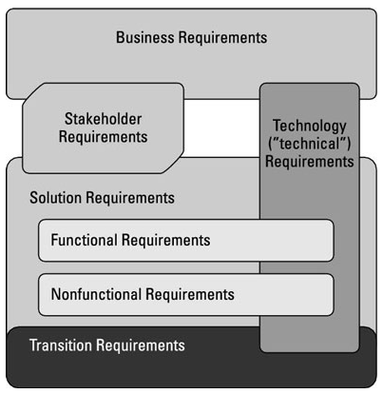

Figure 1 - A depiction of the relationship between the types of requirements.

## Business Requirements

|  |  |  |
| --- | --- | --- |
| ID | Requirements Description | Priority |
| **BR001** | The solution shall have an option to select from potential ancillary products available to business | Must |
| **BR002** | The solution shall allow you to select if you are a creating a new product, making modifications to an existing product, or deleting an existing product | Must |
| **BR003** | The solution shall *only* present fields required by requested product(s)  *e.g. Customer Name presented once, and used for each product* | Must |
| **BR004** | When common fields (e.g. Customer Name) are used throughout multiple products, they will only be prompted for once. | Must |
| **BR005** | The solution shall be able to export data to all required forms vendor format, where applicable | Must |
| **BR006** | The solution shall be accessible to all staff requiring these forms throughout CWB | Must |
| **BR007** | The solution shall be available at all times (excluding normal maintenance outages) | Must |
| **BR008** | The solution shall allow users to save at any point | Must |
| **BR009** | The solution shall allow users to easily retrieve incomplete (saved) forms | Must |
| **~~BR010~~** | ~~The solution shall export completed and signed forms into a locked, uneditable format (e.g. Secure PDF)~~ | ~~Must~~ |
| **BR011** | The solution shall be able to send completed form(s) via email | Must |
| **BR012** | The solution shall be compatible with OneSpan Sign | Should |
| **BR013** | The solution must be able to track which employee created or edited the form | Should |
| **BR014** | The solution shall be able to ensure client emails addresses, if entered, follow standard email formatting rule | Must |
| **BR015** | The solution must be able to store how a document was signed, whether electronically (e.g. via OneSpan Sign) or wet ink. | Should |
| **BR016** | The solution shall be user friendly, intuitive, and visually appealing | Must |
| **BR017** | The solution shall be able to minimize risk by capturing reliable data and ensuring that the data is protected, private, and secure | Must |
| **BR018** | The solutions shall present the consolidated Master Service Agreement for any/all of the products selected New or Modify (the MSA does not have to be included for Delete) | Must |
| **BR019** | The existing forms being replaced will be inaccessible by front line staff through normal means  ***!Note:*****Form 4209 CWBdirect Business Online Banking User Permissions – including wires sections** is used for Delegated and Non-Delegated clients. This form will have to remain accessible until the Non-Delegated products are retired. | Must |
| **BR020** | The solution will be expandable to easily include future products | Must |
| **BR021** | The solution will be able to be easily modified to adapt to product changes and updates | Must |
| **BR022** | The solution shall contain a data validation method to ensure fields have been filled out with appropriate information for that field (e.g. A phone number field contains 10 digits) | Must |
| **BR023** | The final output from the onboarding process will follow CWB Logo and Branding Standards.  ***!Note:*** *CWB Logo Use Standards are attached in Section 3, Related Document References.* | Must |
| **BR024** | The solution shall be able to export data to all required client forms, where applicable | Must |
| **BR025** | The solution shall present information collected that is unique to each product on separate pages on the output of the completed artifact(s) | Must |
| **BR026** | The solution shall be able to store the completed artifact electronically | Must |
| **BR027** | The solution shall be able to send the completed artifact electronically, e.g. email as an attachment | Must |
| **BR028** | The solution shall be able to automatically create and attach completed forms to Service Now | Could |
| **BR029** | The solution shall have the option to ~~sign electronically,~~ print for a physical signature, or save to be sent as an attachment for signature | Must |
| **BR030** | The solution shall present the product names of the products the client is agreeing to next to the signature section | Must |
| **BR031** | Documentation will be stored to allow for future ease of retrieval | Must |
| **BR032** | The solution shall ensure that all required information is collected based on the products the client selects | Must |
| **BR033** | The solution shall ensure that all dates are easily entered | Must |
| **BR034** | The solution shall ensure that all dates are stored consistently | Must |
| **BR035** | The solution shall ensure that a copy of the form with editable information is saved | Must |
| **BR036** | The solution shall ensure information entered into the form is stored at regular intervals | Could |
| **BR037** | The solution shall require each individual Authorized Signing Office to only sign once | Must |
| **BR038** | The solution shall have one consolidated Cash Management Support review section | Must |
| **BR039** | The solution shall provide all information gathered to the client | Must |

## Regulatory Requirements

|  |  |  |
| --- | --- | --- |
| ID | Requirements Description | Priority |
| **REG001** | Existing regulatory requirements regarding the data within the onboarding forms will be transferred to the new form/application | Must |

## Stakeholder Requirements

|  |  |  |
| --- | --- | --- |
| ID | Requirements Description | Priority |
| **STAK001** | Any vendor-related forms will continue to be completed (e.g. RDC, CAFT etc.). | Must |

## Solution Requirements

### Functional Requirements

|  |  |  |  |
| --- | --- | --- | --- |
| ID | Requirements Description | Priority | Business Rule Xref |
| **FUNC001** | The user will have the option to choose from the following products:   * CWBdirect Business Online Banking * CWB Wire Service * Customer Automated Funds Transfer (CAFT)   + Direct Deposit (Credit Files)   + Pre-Authorized Debits (Debit Files)   + Onboarding   + Credit File Risk Assessment   + CAFT 3rd Party Setup * Corporate Remote Deposit Capture (cRDC) * Business Visa (Collabria Visa) | Must | BR001 |
| **FUNC002** | The user will have the ability to choose the “activity” per product selected. The activities will be:   * New * Modify * Delete | Must | BR002 |
| **FUNC003** | Using the field matrix in Appendix A, the system will prompt the user for all required information | Must | BR003  BR004 |
| **FUNC004** | Appropriate vendor-like forms will be part of the printable artefacts generated by the new form/application. When a field does not appear in the Consolidated Form, it will appear blank on the completed artifact provided to CMS. | Must | BR005 |
| **FUNC005** | The following vendor forms will be available:   * CAFT   + Mapping and Raw form can be found in Appendix B * Central 1   + Mapping and Raw form can be found in Appendix D | Must | BR005 |
| **FUNC006** | When the printable artifact is generated, the new Master Service Agreement (MSA) will be appended to the end (where applicable i.e. not for delete, or Visa only).  ***!Note:*** *The new MSA is attached in Section 3, Related Document References.* | Must | BR018 |
| **FUNC007** | The output of the completed artifact can be:   * Printed * Print to PDF, or * Print to OneSpan Sign (if user has been set up with OneSpan Sign) | Must | BR012 |
| **FUNC008** | Completed forms will be in an email-friendly format | Must | BR011 |
| **~~FUNC009~~** | ~~Completed forms will be locked, uneditable~~ | ~~Must~~ | ~~BR010~~ |
| **FUNC010** | The user will be able to save the data collected at any point, and have the ability to retrieve and continue at any time. | Must | BR008  BR009 |
| **FUNC011** | All CWB staff, both Branch and Corporate staff will have access to the new form/application. | Must | BR006  BR007 |
| **FUNC012** | All forms will have an audit history tracked and included on the final artifact, including items such as:   * Last User to edit * All Users that edit the form * Last Modified Date * Create Date * Creation User * Last Save Date | Must | BR013 |
| **FUNC013** | Data entry rules will be followed, found in Mapping can be found in Appendix A Field Matrix | Must | BR014 |
| **FUNC014** | User will have the following options for obtaining signatures:   * ~~Click to sign~~ * Print for wet ink * Print for digital signature (OneSpan Sign)   + This option will only be available for those who have the OneSpan Sign signature   + Until OneSpan Sign functionality is incorporated directly into the application/form, the user will only have the option to print to “OneSpan Sign” to get digital signatures. | Must | BR015 |
| **FUNC015** | The following forms will not be available for general user (but will be available for emergency backup):   * Form 4288 CWBdirect Business Online Banking Application and Agreement – Delegated including wires sections * Form 4209 CWBdirect Business Online Banking User Permissions – including wires sections * Form 4335 CWB Wire Service Checklist * Form 4336 Standalone CWB Wire Service * Form 4122- CAFT Customer Automated Funds Transfer Agreement for Direct Deposit (Credit Files) * Form 4129- CAFT Customer Automated Funds Transfer Agreement for Pre-Authorized Debits (Debit Files) * Form 4164 – CAFT Onboarding form * Form 4028 – CAFT Credit File Risk Assessment * Form 4163 – CAFT File Upload information form * Form 4338 RDC Application and Agreement * Central 1 RDC form * Form 4097 Business Visa Application * Form 4293 Request for Visa card changes * Form 4294 Business Visa – Credit Limit Increase * ~~Form 4289 Visa Disclosure~~ * ~~CAFT (Form 4161)~~ * ~~Business Visa (eZBusiness Online Card Management Tool Internal Request Form)~~ * ~~CWB Wire Service~~ | Must | BR019 |
| **FUNC016** | The CAFT 3rd Party Software Setup (4163) will be available to be provided to the client   * + Mapping and Raw form can be found in Appendix C | Must | BR024 |
| **FUNC017** | The completed artifact will be have separate pages for each of the following:   * General Information (fields required on more than one product) * CAFT (if product selected) * CWBdirect Business Online Banking (if product selected) * CWB Wires (if product selected) * cRDC (if product selected) * CWB VISA (if product selected) * ~~CAFT Internal (if product selected)~~ * ~~Business VISA eZBusiness Internal (if product selected)~~ * ~~CWB Wire Internal (if product selected)~~ | Must | BR025 |
| **FUNC018** | The form/application shall include a disclosure statement next to the signature line | Must | BR030 |
| **FUNC019** | The form/application will present the products the client has selected and note if they are New Products, Modifications to an existing Product(including the type of Modification(s)), or Deletions of a product under the disclosure statement.  Each Product should be on a separate line. Type of Modifications can be on the same line but separated by commas.  For example if Acme Corp is signing up for Business VISA and Wires, and is making modifications to CAFT the user will be presented with the following by disclosure statement:  Business VISA - New WIRES - New  CAFT – Modify – General Information, Users | Must | BR030 |
| **~~FUNC020~~** | ~~If the user has selected “~~**~~Click to sign~~**~~”, when the form/application is completed it will present the completed artifact to the user to be saved in an electronic format that can be emailed~~ | ~~Must~~ | ~~BR027~~ |
| **~~FUNC021~~** | ~~If the user has selected “~~**~~Click to sign~~**~~”, when the form/application is completed it will present an option to send directly via ServiceNow. If the option is selected, the form will create the appropriate ServiceNow ticket, in the users name, and attach the completed artifact.~~ | ~~Could~~ | ~~BR028~~ |
| **FUNC022** | If the user has selected “**Physical signature**”, when the form/application is completed it will present the completed artifact, including a signature page, to the user to be saved and printed for a physical signature. | Must | BR027 BR029 |
| **FUNC023** | If the user has selected “**Email for signature**”, when the form/application is completed it will present the completed artifact, including a signature page, to the user to be saved and emailed for a signature. | Must | BR027 BR029 |
| **FUNC024** | The completed artifact will be saved with a title that includes “**The Legal Name of the Business**” from the form and the Date Completed | Must | BR031 |
| **FUNC025** | The completed artifact will follow the FileNet tagging conventions for CMS (e.g. tags for CIF, Product, Originator Number) | Must | BR031 |
| **FUNC026** | The Field Matrix, in Appendix A, designates which fields will be presented based on the products selected (e.g. If Wires is selected, present the field for CIF). There are also other fields to be presented based on responses to other questions (e.g. If the response to ‘Is the Mailing Address different than the Physical Address’ is Yes, present the fields for Mailing Address as outlined). | Must | BR032 |
| **FUNC027** | If a field is presented it is mandatory to complete the form. If a mandatory field is not filled out, or not filled out correctly, when the user selects “**Sign Form**” the form/application will not allow the user to proceed, and will highlight the fields that are not filled out and note errors (for example “CIF not filled out” or “CIF must contain numbers only”) | Must | BR032 |
| **FUNC028** | The solution shall present a calendar for all date fields | Must | BR033 |
| **FUNC029** | The solution shall store all dates in the format DD Full Month, YYYY | Must | BR034 |
| **FUNC030** | The solution shall require the user to save a copy of the form, with editable information, before presenting the option to print. | Must | BR035 |
| **FUNC031** | The solution shall automatically save information entered into the form at regular intervals (every 5 minutes) | Could | BR036 |
| **FUNC032** | The solution shall remove the signature sections from the individual forms presented on the completed artefact (e.g. 4097 CWB Business Visa Application will not have a signature section) | Must | BR037 |
| **FUNC033** | The solution shall present a consolidated signature section that will be presented on the completed artefact | Must | BR037 |
| **FUNC034** | The solution shall present all information gathered on the Form Wizard on the final artifact, regardless of whether or not it appears in the child forms | Must | BR039 |
| **Func035** | The solution shall present all the required forms in one consolidated artifact | Must | BR025 |
| **FUNC035** | The solution shall present the forms below in the following order on the consolidated artifact   * Form Wizard (Excluding the Signature Section) * Online Banking Child Forms (if required) * RDC Child Forms – including Central 1 RDC form (if required) * CWB Wires Services Child Forms (if required) * CAFT Services Child Forms (if required) * Visa Child Forms (if required) * Form Wizard Signature Section including the:   + CWBDirect Business Online Banking Resolutions (if required)   + CWBDirect Certificate of Authorized Representatives (if required) * Master Service Agreement * Audit Page (Client Solutions to Provide Feedback)   + Who created - Date   + Who modified - Date   + Who submitted – Date * Consolidated Cash Management Support Section | Should | BR025 |

### Non-Functional Requirements

|  |  |  |  |  |  |
| --- | --- | --- | --- | --- | --- |
| ID | | Requirements Description | | Priority | |
| **NFUN001** | The new form/application will be easy to use | | Must | | BR016 |
| **NFUN002** | The new form/application will be compatible with OneSpan Sign | | Should | | BR015 |
| **NFUN003** | The new form/application will be easily expandable to add more products, if required | | Must | | BR021 |
| **NFUN004** | The new form/application will protect saved data | | Must | | BR017 |
| **NFUN005** | The new form/application will be compatible with FileNet | | Must | | BR026 |
| **NFUN006** | The new form/application will be compatible with ServiceNow | | Should | | BR027 |

#### Service Level Requirements

|  |  |  |
| --- | --- | --- |
| ID | Requirements Description | Priority |
|  | N/A |  |

## Transition Requirements

|  |  |  |
| --- | --- | --- |
| ID | Requirements Description | Priority |
| **TRAIN001** | This initiative has partnered with Learning and Development to generate and perform training. | Must |
| **OCM001** | This initiative has partnered with OCM to facilitate the OCM communications | Must |

# Assumptions, Dependencies and Constraints

## Assumptions

The following assumptions have been made regarding this project. Each assumption is an ‘educated guess’, a likely condition, circumstance or event, presumed known and true in the absence of absolute certainty. Assumptions are made to fill knowledge gaps; they may later prove to be incorrect but could have a significant impact on the project\initiative.

|  |  |  |
| --- | --- | --- |
| Ref | Assumption | Impact |
|  | N/A |  |
|  |  |  |

## Dependencies

The following list of business related dependencies have been identified during the requirements development effort. Dependencies may include the availability of resources, business processes, regulatory approvals, roadmaps, etc. Of particular importance are the dependencies on the availability of stakeholders and users, and conformance to approval and change management processes.

|  |  |  |
| --- | --- | --- |
| Ref | Dependency | Comments |
| **DEP001** | Vendor forms are supplied in a format usable by the new application/form. | RDC Form from Central 1  CAFT Form from CUPS |
| **DEP002** | The FileNet Structure for CMS will be defined and in place |  |

## Constraints

The following constraints have been identified during the requirements gathering process:

|  |  |  |  |
| --- | --- | --- | --- |
| Ref | Constraint | Description | Response |
|  | N/A |  |  |

# Business Benefits

**Employees**:

The information below notes the number of times CMS had to request more information from a branch regarding onboarding forms. This was collected by CMS over the month of December, which is typically a slower month.

|  |  |  |  |  |
| --- | --- | --- | --- | --- |
| Total Number of requests | Number of incorrect requests | Missing Info (not signatures) | Incorrect  or Missing Signatures | Incorrect  Information |
| 420 | 212 | 19.52% | 6.67% | 19.05% |

Assuming an average of 5 minutes of work by CMS to note the error and send back to the branch, and a further 15 minutes of work by the branch to correct the error, this leads to 70 hours of additional work per month. Simplifying the forms for setting up clients with ancillary products will conservatively reduce the number of errors by 50%. This represents a significant reduction in the amount of work required by Branch and CMS personnel.

**Client:**

Our clients will benefit from a streamlined onboarding process for ancillary products. They will spend less time filling out forms for these products, Staff will not have to reach out to them for additional information (as the number of errors made filling out these forms is reduced), and they will be able to begin using these products sooner. Reducing the number of errors made when filling out these forms will lead to a better overall client experience and improve the reputation of the Bank.

# Business Risks

|  |  |
| --- | --- |
| Ref: | **1** |
| Risk | Resourcing |
| Description | As this initiative is not a formal project, resourcing may be a challenge to fulfill the needs of the initiative. |
| Probability | High |
| Impact | High |
| Severity | High |
| Mitigation | * This high priority operational initiative has been discussed to all stakeholders to aid in scope definition * Touchpoint meetings to keep each other on track |

# Business Rules

|  |  |  |  |
| --- | --- | --- | --- |
| Identifier | Business Rule Name | Description | Priority |
| BRL001 | Client Information | Client information would have to be entered into T-24 before filling out these forms | Must |
| BRL002 | Multi Entity Organizations | When multi entity organizations are signing up for these products, a Power of Attorney must be provided by the child organization granting authority for the parent organization to post on its behalf (e.g. Acme trucking must provide a Power of Attorney for Acme Corp to post on its behalf). | Must |
| BRL003 | Changes to Submitted Forms | Any changes required to submitted forms (i.e. forms submitted to CMS that are incorrectly filled out) will be made to the saved form and must be signed by client to ensure they are aware of the change. | Must |

# Signature

This section contains the signatures of the primary key stakeholders indicating acknowledgement and acceptance that the information collected in this document represents the interests of all business area stakeholders listed in the Stakeholder section.

|  |  |  |  |
| --- | --- | --- | --- |
| Role | Name & Title | Date | Digitally Approved |
| Business Sponsor | Jo Gould,  Senior Manager, Cash Management, Sales & Marketing | 5/11/2018 |  |
| Business Subject Matter Expert | Ram Sidhu,  Manager, Digital Sales & Marketing | 5/11/2018 | *Add to history that doc was digitally approved* |
| Business Subject Matter Expert | Gurdy Bains,  Manager, CMS | 5/11/2018 | X |
| Business Subject Matter Expert | Jane Teo, Mgr,  AML Program Development | 5/11/2018 |  |
| Business Analyst | James McFarlane,  Business Analyst | 5/11/2018 | *Add to history that doc was digitally approved* |

Signature for Version 0.4

|  |  |  |  |
| --- | --- | --- | --- |
| Role | Name & Title | Date | Approval |
| Business Sponsor | Jo Gould,  Senior Manager, Cash Management, Sales & Marketing | 7/10/2018 |  |
| Business Subject Matter Expert | Ram Sidhu,  Manager, Digital Sales & Marketing | 7/10/2018 |  |
| Business Subject Matter Expert | Gurdy Bains,  Manager, CMS | 7/10/2018 |  |
| Business Subject Matter Expert | Jane Teo, Mgr,  AML Program Development | 7/10/2018 |  |
| Business Analyst | James McFarlane,  Business Analyst | 7/10/2018 |  |

Signature for version 0.5

|  |  |  |  |
| --- | --- | --- | --- |
| Role | Name & Title | Date | Approval |
| Business Sponsor | Jo Gould,  Senior Manager, Cash Management, Client Solutions | 12/24/2018 |  |
| Business Subject Matter Expert | Kristen En,  Product Manager, Cash Management Products | 12/24/2018 |  |
| Business Subject Matter Expert | Gurdy Bains,  Manager, CMS | 12/24/2018 |  |
| Business Subject Matter Expert | Jane Teo, Mgr,  AML Program Development | 12/24/2018 |  |
| Business Analyst | James McFarlane,  Business Analyst | 12/24/2018 | *Add to history that doc was digitally approved* |

Signature for version 0.6

|  |  |  |  |
| --- | --- | --- | --- |
| Role | Name & Title | Date | Approval |
| Business Sponsor | Jo Gould,  Senior Manager, Cash Management, Client Solutions | 3/4/2019 |  |
| Business Subject Matter Expert | Kristen En,  Product Manager, Cash Management Products | 3/4/2019 |  |
| Business Subject Matter Expert | Gurdy Bains,  Manager, CMS | 3/4/2019 |  |
| Business Subject Matter Expert | Jane Teo, Mgr,  AML Program Development | 3/6/2019 |  |
| Business Analyst | James McFarlane,  Business Analyst | 3/6/2019 | *Add to history that doc was digitally approved* |

Signature for version 0.7

|  |  |  |  |
| --- | --- | --- | --- |
| Role | Name & Title | Date | Approval |
| Business Sponsor | Jo Gould,  Senior Manager, Cash Management, Client Solutions | 3/4/2019 |  |
| Business Subject Matter Expert | Kristen En,  Product Manager, Cash Management Products | 3/4/2019 |  |
| Business Subject Matter Expert | Gurdy Bains,  Manager, CMS | 3/4/2019 |  |
| Business Subject Matter Expert | Jane Teo, Mgr,  AML Program Development | 3/6/2019 |  |
| Business Analyst | James McFarlane,  Business Analyst | 3/6/2019 | *Add to history that doc was digitally approved* |

# Appendix A Field Matrix

The attached Field Matrix outlines which fields are required for conditional display based on products selected. The following Legend outlines how to read the Field Matrix.

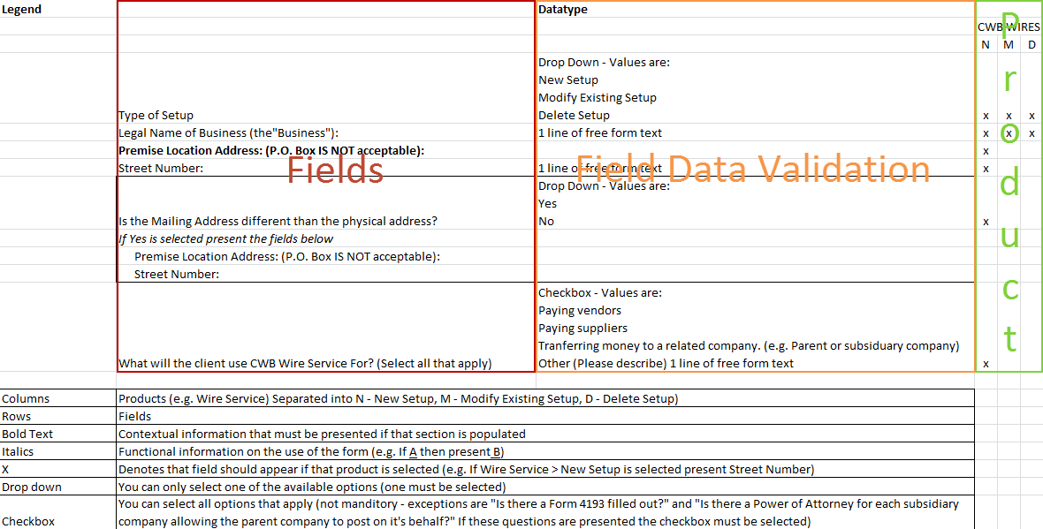

As complexities have arisen the Field Matrix has been split by product and placed on the [SharePoint](https://sp.cwb.local/collaboration/bpb/businessbanking/Shared%20Documents/Forms/AllItems.aspx?RootFolder=/collaboration/bpb/businessbanking/Shared%20Documents/CMS%20Onboarding%20Forms%20Consolidation%20Initiative/Requirements/Final&InitialTabId=Ribbon.Document&VisibilityContext=WSSTabPersistence) site for the initiative. Note – we have removed the Action column, as in the Final version all fields required for that specific action are identified by Tab. Below is the updated legend: 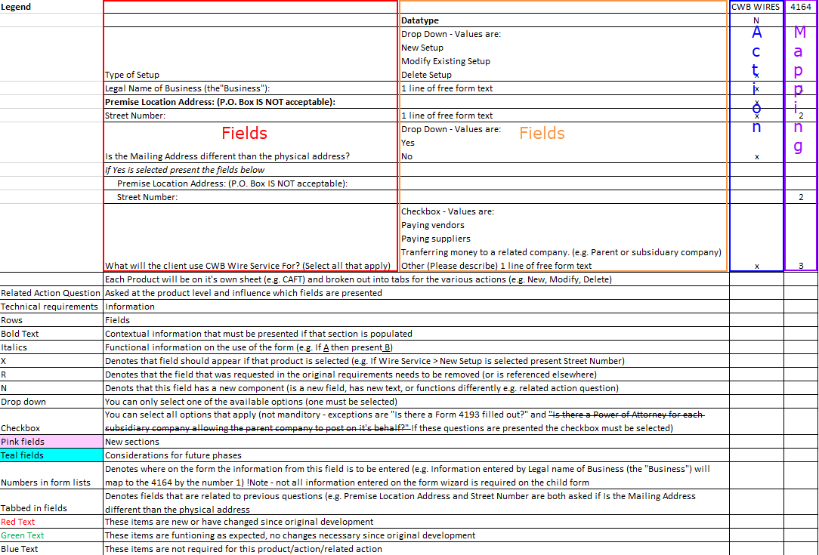

# Appendix B Field Mapping for CAFT

The following maps the field labels from the Field Matrix to the required fields on the CAFT 3rd Form (4164). If CAFT is selected as one of the products the client would like to sign up for, populate the following form to be provided to the Vendor (CUPS).

# Appendix C Field Mapping for CAFT 3rd Party Software Setup

The following maps the field labels from the Field Matrix to required fields on the CAFT 3rd Party Software Setup Form (4163). If File Upload is selected as Originator Type, populate the following form to be provided to the client.

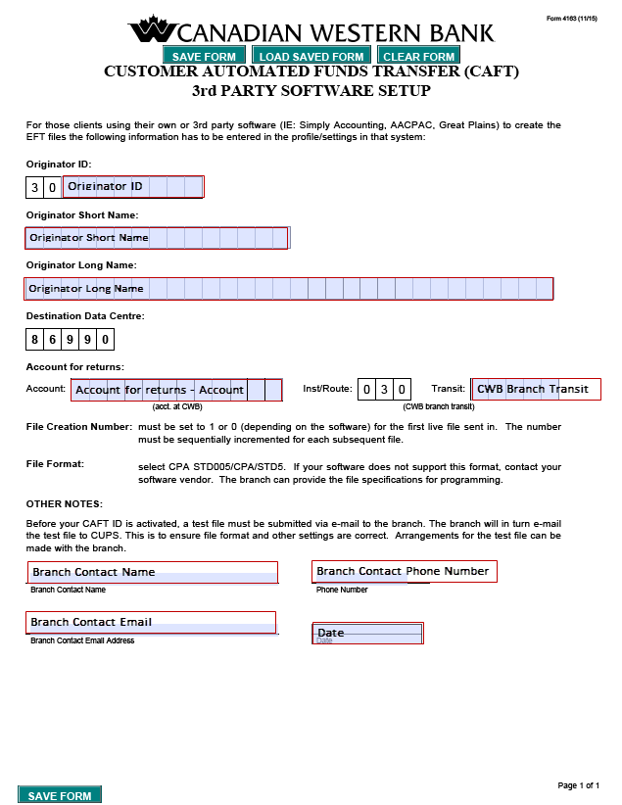



# Appendix D Field Mapping for RDC

The following maps the field labels from the Field Matrix for the required fields on the Central 1 RDC Form. If RDC is selected as one of the products the client would like to sign up for, populate the following form to be provided to the Vendor (Central 1).

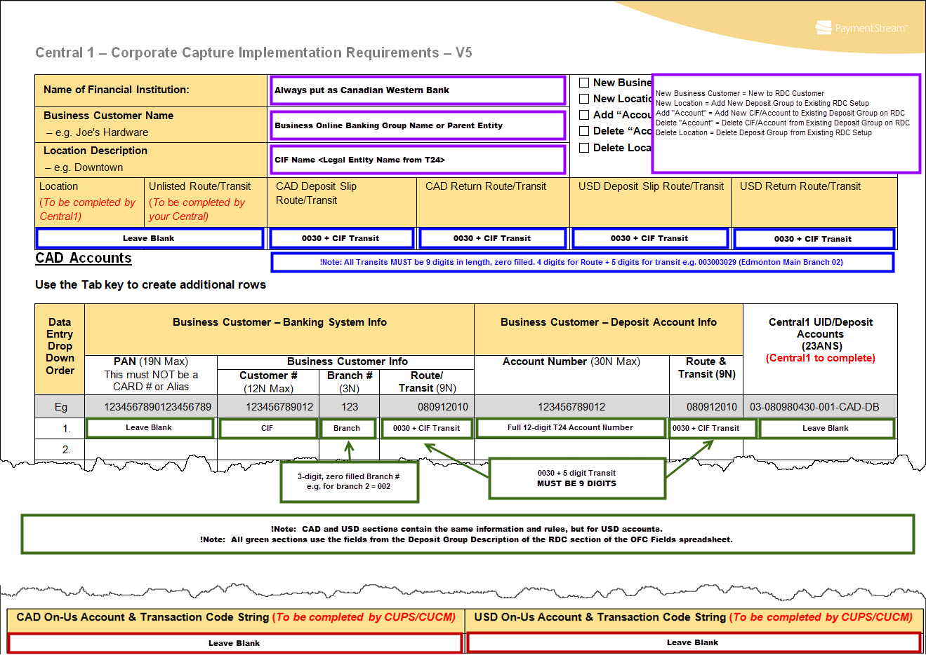



***!Note:*** *As the above pending requirements are defined, minor changes to the business and functional requirements may be required. These changes will be change requested and managed through project management processes*. *This essentially implies that the BRD will be “locked” once signed, with the exception of the areas listed above*

# Appendix E Master Service Agreement

The attached MSA contains Terms and Conditions for all products included in the Consolidated Forms with the exception of Visa. As the Terms and Conditions for Visa outline an agreement with Collabria these are incompatible with the rest of the MSA. If clients sign up for Visa standard procedure will be to fill provide the MSA when the clients sign up, and provide the Visa Disclosure (Form 4289) once the application has been approved and Visa Account Number has been supplied as is the case today.

